**W1-S2** PRACTICE

*DART BASICS*

## *Before this practice*



* You need to have completed: **SELF-LEARNING 1** - Dart Syntax & Concepts

## *Learning objectives*

* Apply type **inference** for variable declarations.
* Handle **nullable** and **non-nullable** variables.
* Differentiate between **final** and **const**.
* Manipulate **strings, lists, and maps.**
* Use **loops** and **conditions** to control flow.
* Define and call functions with positional and **named arguments**, understand **arrow syntax**

 *No AI tools allowed to solve this practice*

## *How to submit?*

* **Push your final code** on this GitHub repository (if you are lost, [follow this tutorial](https://www.datacamp.com/tutorial/git-push-pull))

## *Are you lost?*

*Read the following documentation to be ready for this practice:*

* [Variables](https://dart.dev/language/variables)
* [Null Safety](https://dart.dev/null-safety)
* [Built-in types](https://dart.dev/language/built-in-types)
* [Lists](https://dart.dev/language/collections)
* [Loops](https://dart.dev/language/loops)
* [Conditions](https://dart.dev/language/branches)
* [Functions](https://dart.dev/guides/language/language-tour#functions)

# REVIEW SELF-LEARNING

In group of 3 or 4, **review the** self-learning work.

* After discussing with your peer, **update your answers** if you need
* Some groups will present **their outcome** to the classroom

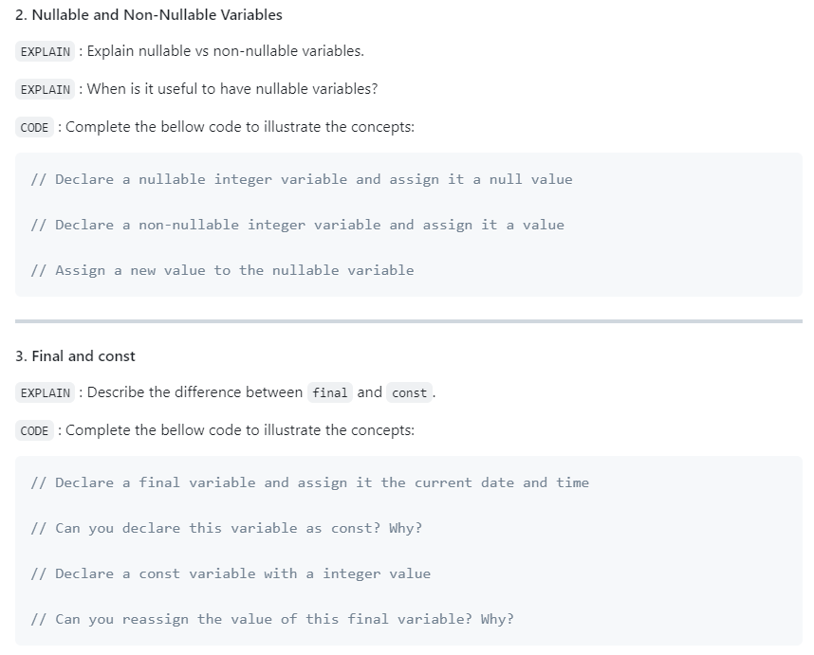

*Review, and update your answer regarding your work*

# EX 1 – Manipulate Types

*Are you clear about strings, integer, list, map, set, objects in Dart?*

Examine the given data structures and **write the inferred Dart type** for each one (*see example*)

*Notes*

* *First find by yourself the type*
* *If you need, double check your answer with VSCode.*

|  |  |
| --- | --- |
| **Data** | **Dart Type** |
| const studentGrades = {  'Sokan': [90, 85, 88],  'Sokea': [70, 80, 75],  'Hay': [95, 92, 89],  }; | Map<String, list<double>> |
| const pizzaPrices = {  'margherita': 5.5,  'pepperoni': 7.5,  'vegetarian': 6.5,  }; | Map<String, float> |
| const books = [  {'title': '1984', 'author': 'George Orwell'},  {'title': 'Brave New World', 'author': 'Aldous Huxley'},  {'title': 'Fahrenheit 451', 'author': 'Ray Bradbury'},  ]; | List<Map<String, int ,String>> |
| const company = {  'HR': {'employees': 5, 'budget': 20000},  'IT': {'employees': 10, 'budget': 50000},  'Marketing': {'employees': 7, 'budget': 30000},  }; | Map<String , Map<string, int>> |
| const coordinates = [  [1, 2],  [3, 4],  [5, 6],  ]; | List<List<int>> |
| const productDetails = {  'id': 101,  'name': 'Laptop',  'price': 999.99,  'inStock': true,  }; | Map<String, dynamic> |
| const operations = [  (int a, int b) => a + b,  (int a, int b) => a - b,  (int a, int b) => a * b,  ]; | List<int> |
| const distances = {3.1, 5.5, 10.2, 7.8}; | Map<double> |
| const university = {  'departments': [  {  'name': 'Computer Science',  'students': [  {'name': 'Alice', 'age': 22},  {'name': 'Bob', 'age': 24},  ]  },  {  'name': 'Mathematics',  'students': [  {'name': 'Charlie', 'age': 21},  {'name': 'Dave', 'age': 23},  ]  }  ]  }; | Map<String, List<Map<String, String, List<Map<String, String ,int>>>>> |

# EX 2 – Manipulate final and const

In this exercise, you need to decide which variable can be declared as **const** or **final**.

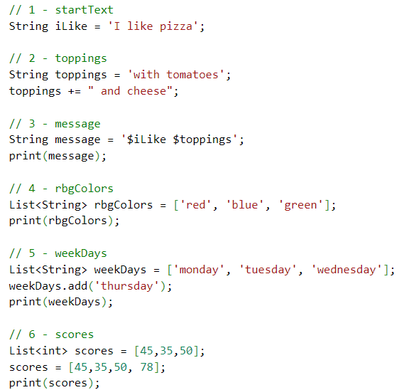

Guess which variables can be declared as **const**, **final** or **var**, and explain your choices.

*Notes*

* *Read* [*here*](https://dart.dev/language/variables) *to understand the concepts.*
* *Prefer const over final over var.*

|  |  |  |
| --- | --- | --- |
|  | **VAR, FINAL, CONST?** | **WHY** |
| iLike | CONST | *Because this variable never changes* |
| toppings | VAR | *Because this variable always changes* |
| message | FINAL | *Because this variable can’t be change* |
| rbgColors | CONST | *Because this variable have give the values* |
| weekDays | FINAL | *Because this variable can be change* |
| score | VAR | *Because this variable can be change* |

# EX 3 – Filter a list

**Instructions**

* You are given a list of integers representing the scores of students in an exam.
* A score of 50 or higher is considered passing.
* Write a Dart program that filters and returns a list of students and the number of students who passed the exam.

**Constraints**

* You must use the **where** function with a proper **anonymous function** to filter the original list
* More information [here](https://medium.com/@yousafjamil50/where-method-in-dart-flutter-16d6d13d8afb)

**Examples**

INPUT

[45, 78, 62, 49, 85, 33, 90, 50]

OUTPUT

[78, 62, 85, 90, 50]

5 students passed

# EX 4 – Manipulate maps

Given the following **map** of pizza prices:

const pizzaPrices = {

'margherita': 5.5,

'pepperoni': 7.5,

'vegetarian': 6.5,

};

Write a program to calculate the total for a given order.

For example, given the following order:

const order = ['margherita', 'pepperoni'];

The program should print:

Total: $13`

If a pizza is not on the menu, the program should print:

pineapple pizza is not on the menu

*BONUS 1 – Write a robot simulator*

A robot factory's test facility needs a program to verify robot movements.

The robots have three possible movements:

* turn right
* turn left
* advance

Robots are placed on a hypothetical infinite grid, facing a particular direction (NORTH, EAST, SOUTH, OR WEST) at a set of {X, Y} coordinates, e.g., {3,8}, with coordinates increasing to the north and east.

The robot then receives a number of instructions, at which point the testing facility verifies the robot's new position, and in which direction it is pointing.

As example

* the string "RAALAL" means:

1. Turn right
2. Advance twice
3. Turn left
4. Advance once
5. Turn left yet again

* Say a robot starts at {7, 3} facing north.
* Then running this stream of instructions should leave it at {9, 4} facing west.

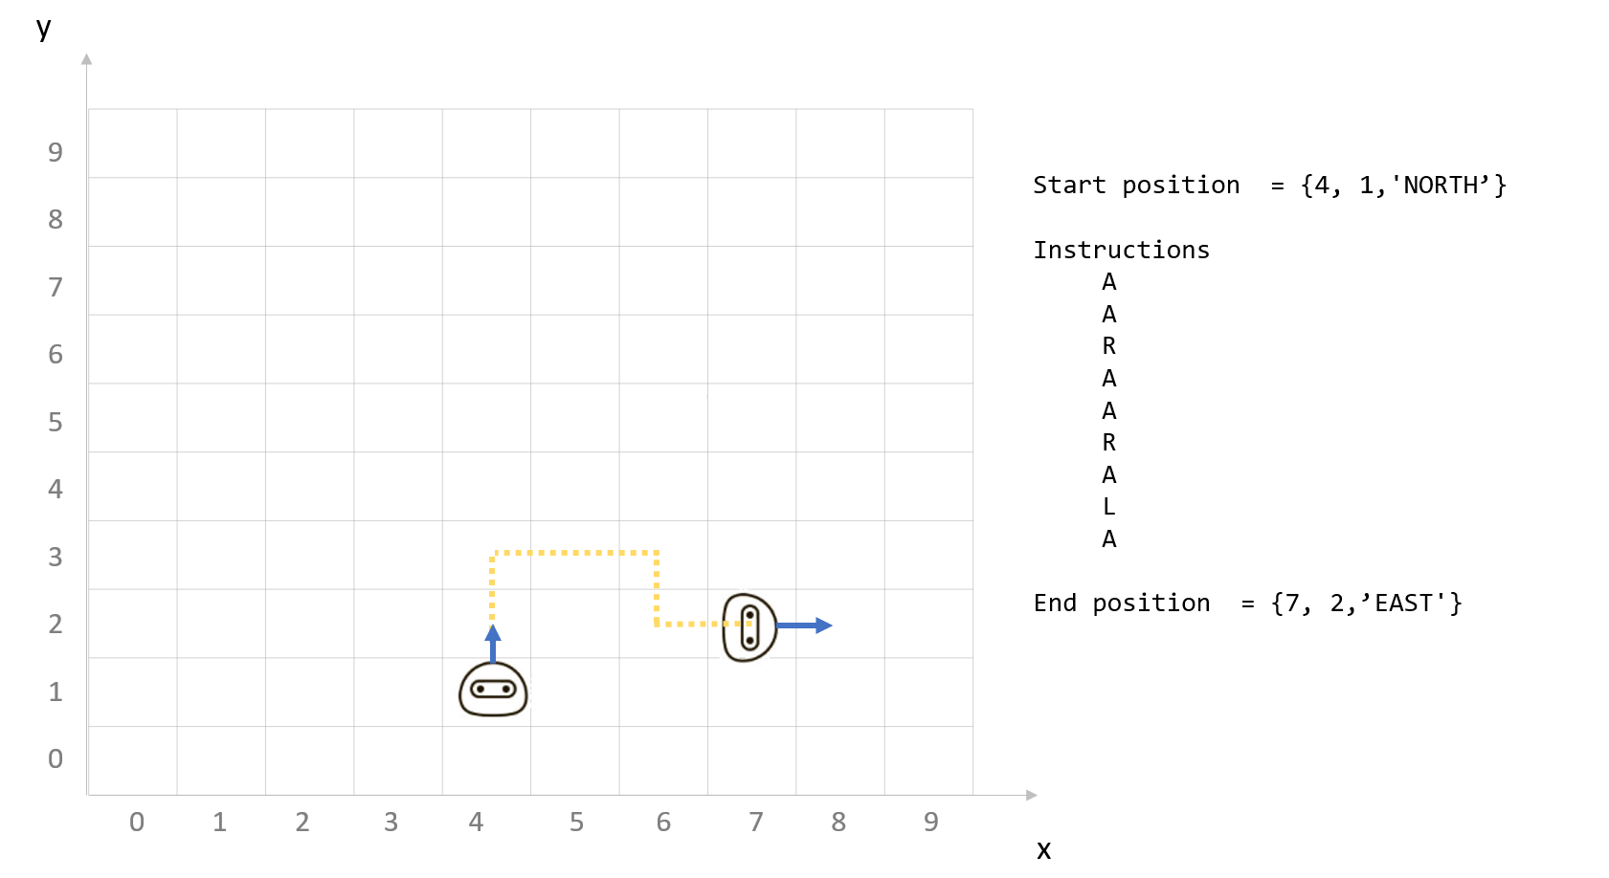

**Note**

* You are free to decide how to structure your data in Dart language
* Try to use as much as possible functions to separate your logic

*BONUS 2 – Matching Brackets*

**Instructions**

Given a string containing brackets [], braces {}, parentheses (), or any combination thereof, verify that any and all pairs are matched and nested correctly. Any other characters should be ignored.

**Examples**

|  |  |
| --- | --- |
| INPUT | OUTPUT |
| {what is (42)}? | Balanced |
| [text} | Not balanced |
| {[[(a)b]c]d} | Balanced |